**Dockerfile for Tomcat**

**Step1: Creating Docker Tomcat Image – Example**

First Let us start with Creating a New Directory (workspace) in which we are going to create our Dockerfile and Copy the Web Applications and other configuration files which needs to be shared with the Container.

You can also use the Existing directory but creating a new and Separate directory for your all your container projects are recommended for Clean infrastructure

**Creating a Work Space Directory (or) Use the Existing one.**

I have created a new directory named "/apps/docker/DockerTomcat"  Along the way till the end of this article, I would refer this directory as  WORKSPACE directory

**Creating a DockerFile – Docker Tomcat Image**

Inside the workspace,  we are going to create a Dockerfile with the following content

Note*: Dockerfile must start with ‘D’ as upper case.

FROM centos

MAINTAINER somename

RUN mkdir /opt/tomcat/

WORKDIR /opt/tomcat

RUN curl -O https://www-eu.apache.org/dist/tomcat/tomcat-8/v8.5.40/bin/apache-tomcat-8.5.40.tar.gz

RUN tar xvfz apache*.tar.gz

RUN mv apache-tomcat-8.5.40/* /opt/tomcat/.

RUN yum -y install java

RUN java -version

WORKDIR /opt/tomcat/webapps

RUN curl -O -L https://github.com/AKSarav/SampleWebApp/raw/master/dist/SampleWebApp.war

EXPOSE 8080

CMD ["/opt/tomcat/bin/catalina.sh", "run"]

Here

MAINTAINER – Who Crate and manage this container image

FROM – What is the base image, we are going to use to host our container. you can either use a minimal OS image like CentOS, Alpine or you can create your own from the scratch by mentioning SCRATCH as a value to this.

RUN – Commands to Run to make the image( the future container) in the way you want

EXPOSE Do you want your image or application in the image to expose any port to the external world or at least to the host.  For example if you are building Apache HTTP server image you can EXPOSE port 80, In our case it is 8080

CMD The Default Command of the container which gets created using this image.  Every Container must have a Default Command. the Container would run as long as the Default Command is running.

ADD or COPY The files you want to copy into the container from your host.

WORKDIR Define a workspace where the upcoming (or) following set of commands/instructions  should be executed in

Here you can see we have used WORKDIR twice, One is to execute set of commands on the TOMCAT_HOME/CATALINA_HOME  another WORKDIR is to download the Sample Application WAR file and deploy the war into Docker Tomcat Container.

**Note*:  Built-In step for an Application Deployment**

The Docker Container Image we are creating has an instruction to Deploy an application directly from one of our github page (download the war file) and the version of tomcat we are going to build is 8.5.40

Make necassary Changes if you opt for a different version.

Make you get the Downloadable Link of Tomcat right so that your image gets created with no issues.

**Step2: Build the Docker Tomcat Image**

On the same WorkSpace Directory where our Dockerfile is residing. Run the following command to build the image.

The Syntax of the Docker Image command is

docker build -t [Name Of the Image]  .

Here the PERIOD . (DOT) represents the Current working directory which is also part of the syntax

$ docker build -t somename/tomcat8 .

Sending build context to Docker daemon 38.4kB

Step 1/13 : FROM centos

---> 1e1148e4cc2c

Step 2/13 : MAINTAINER somename

---> Using cache

---> af1217ce46de

Step 3/13 : RUN mkdir /opt/tomcat/

---> Using cache

---> 4c38afae9d54

Step 4/13 : WORKDIR /opt/tomcat

---> Using cache

---> a725d7431b50

Step 5/13 : RUN curl -O https://www-eu.apache.org/dist/tomcat/tomcat-8/v8.5.40/bin/apache-tomcat-8.5.40.tar.gz

---> Using cache

---> 91e7bc7726ff

Step 6/13 : RUN tar xvfz apache*.tar.gz

---> Using cache

---> 629328c4f4d2

Step 7/13 : RUN mv apache-tomcat-8.5.40/* /opt/tomcat/.

---> Using cache

---> f501f3c72f61

Step 8/13 : RUN yum -y install java

---> Using cache

---> 345972c4e662

Step 9/13 : RUN java -version

---> Using cache

---> ccb7b9f52541

Step 10/13 : WORKDIR /opt/tomcat/webapps

---> Running in 83e328f92c1a

Removing intermediate container 83e328f92c1a

---> 8e8d29c51fd8

Step 11/13 : RUN curl -O https://github.com/AKSarav/SampleWebApp/raw/master/dist/SampleWebApp.war

---> Running in cdc45a9204a9

% Total % Received % Xferd Average Speed Time Time Time Current

Dload Upload Total Spent Left Speed

100 149 100 149 0 0 66 0 0:00:02 0:00:02 --:--:-- 66

FROM centos

Removing intermediate container cdc45a9204a9

---> b064cd141999

Step 12/13 : EXPOSE 8080

---> Running in dd17c8c97189

Removing intermediate container dd17c8c97189

---> cc5acb3cb1f8

Step 13/13 : CMD ["/opt/tomcat/bin/catalina.sh", "runt"]

---> Running in f8bf12a4e567

Removing intermediate container f8bf12a4e567

---> 2b61f132794e

Successfully built 2b61f132794e

Successfully tagged somename/tomcat8:latest

But why did I name my image as “somename/tomcat8” instead of  just Tomcat8

Here somename is my Docker Login Name / Docker User Name.

It is always recommended to Name the image you are creating with your Docker User Name, So that when you are publishing the Image to Docker hub. ( A Central Shared Repository) it would be easy and People across the world can just download your image by specifying the same Name that you have set.

For Example, If you want to download this image, you can simply use docker pull somename/tomcat8 Thats all.

So when you create your images, Please make sure you use your Docker Login Name.

**Step3: Publish or Push the image to DockerHub**

Before you start publishing the images to DockerHub. It is necessary that you have to create your Docker Hub (or) Docker Account.  Visit  [hub.docker.com](https://hub.docker.com/)

Once you have set up your username in Docker Hub.

Login to Docker Hub from the Docker CLI

$ docker login

Login with your Docker ID to push and pull images from Docker Hub. If you don't have a Docker ID, head over to https://hub.docker.com to create one.

Username: somename

Password:

Login Succeeded

Once the Login succeeded.

Publish/Push the image you have created to Docker Hub. Based on your Internet speed you can see the Upload gets completed in a couple of minutes.

$ docker push somename/tomcat8

The push refers to repository [docker.io/somename/tomcat8]

bfc9fd0939b7: Pushed

f6b1f20ff3ed: Pushed

6d21360e64a0: Pushed

4a62c00a3c78: Pushed

0bc97febfdbb: Pushed

0f861fa8dd99: Pushed

c1117571ffb4: Pushed

071d8bd76517: Mounted from library/centos

latest: digest: sha256:8ede588ad0bb944e62765fdb40b21f7ebdc6587afa00efc7570ede4c7f0786fa size: 1996

Once the image is uploaded (or) Pushed, The entire world can re use your image as we have mentioned earlier using **docker pull**

**Additional: How to download this Docker Tomcat Image?**

You can use docker CLI to download the image directly and create a container.

To Download this image Just use the following DOCKER CLI command

docker pull somename/tomcat8

Once you have downloaded this image, This image would be available in your local image repository.

use either of following commands to make sure the image is present

to list all the images in your local repository use the following command

docker images

to list only the subjected tomcat image use the following command

docker image ls somename/tomcat8

**Do I have to do Docker Pull If I want to download this image before Running it as a container?**

The Answer is **NO**, Docker By default, would download the image from Docker Hub if the image is not available in the local image repository.  So it is not necessary that you have to explicitly do the **docker pull**

**Step4: Run Docker Tomcat image as a container.**

Now the Image is ready and available in Docker Hub. Irrespective of, If the image is available locally or not. You can start the image as a container.

As mentioned earlier,  Docker would search for the image in DockerHub if it is not available in local.

So the command given below can even be run at your Host from anywhere in the world. as long as you are connected to the internet. Docker would do the rest.

$ docker container run -it -d --name tomcatcontainer1 -p 8081:8080 somename/tomcat8

d6f0859b69d216885e8671d9d024f7bdfb82e7a2af1b40fbc8016e36c51313a7

Here

-it: to enable Interactive Session/SSH to get into the container at a later point in time

-d: Run the container in the background (always recommended)

--name: name your container

somename/tomcat8: the Image used to create this container. the Image instantiated as a container

-p 8081:8080:  Forwarding the Container port 8080 to Host 8081

Congratz. we started a Docker Tomcat Container

To quickly verify, if your container use docker ps command. Then at the end of this post we will share more commands to manage your container

**Step5: Access the Deployed/Built-In SampleWebApp**

Since we have port forwarding and redirecting the container 8080 to the Host (mac/windows/linux) 8081. We can access the Sample Web Application installed inside the tomcat container at the following URL

http://localhost:8081/SampleWebApp

In my case, my Host machine is MAC OS so I can directly hit the URL in the browser.

[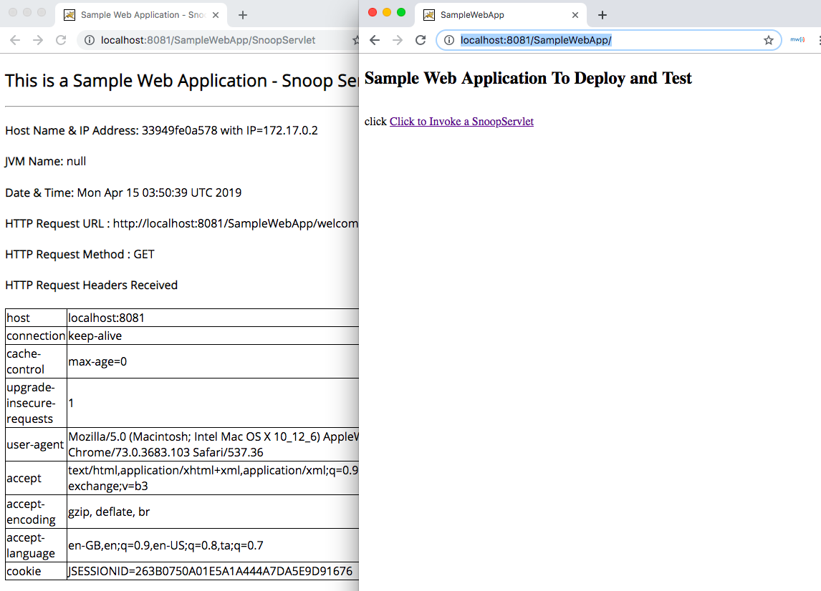](https://www.middlewareinventory.com/wp-content/uploads/2019/04/Screen-Shot-2019-04-15-at-9.21.34-AM.png)